Same-Side Interior Angles
# Source: AI Source: Provided by: [Data Path: Persons Table -> ID Column: 1, Name_En Column: Motasem Essam] -> From: [ChatGPT] on [7/25/2026]
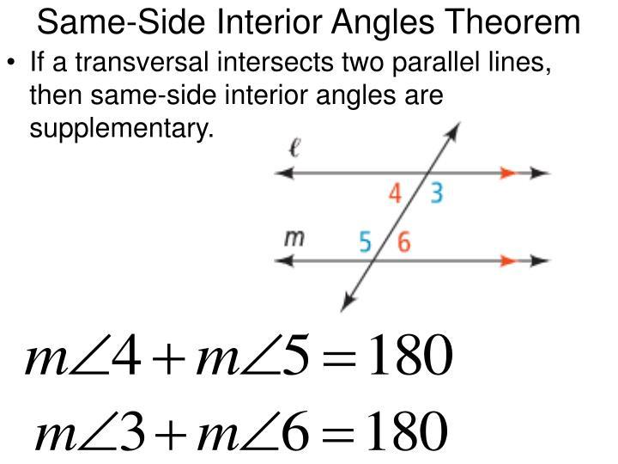
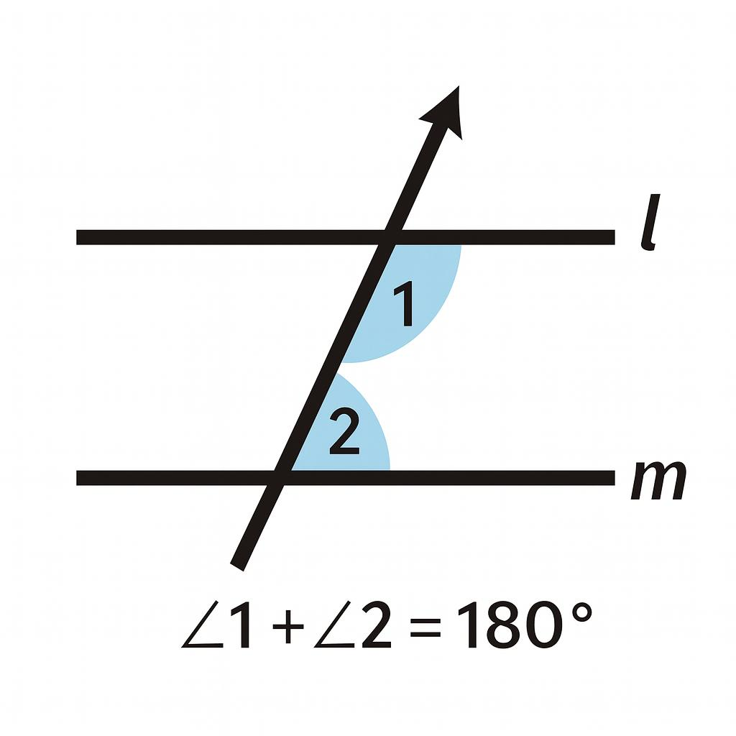
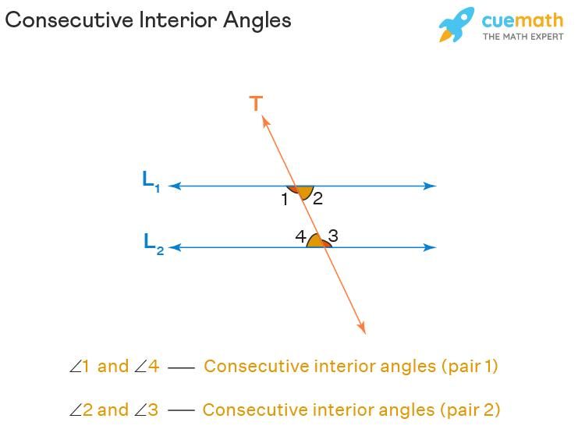
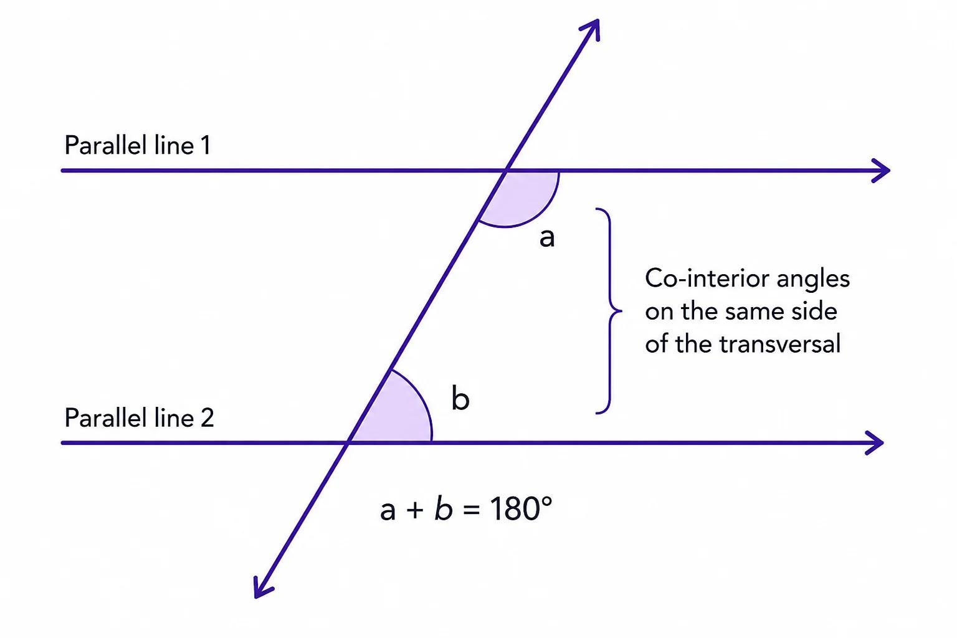
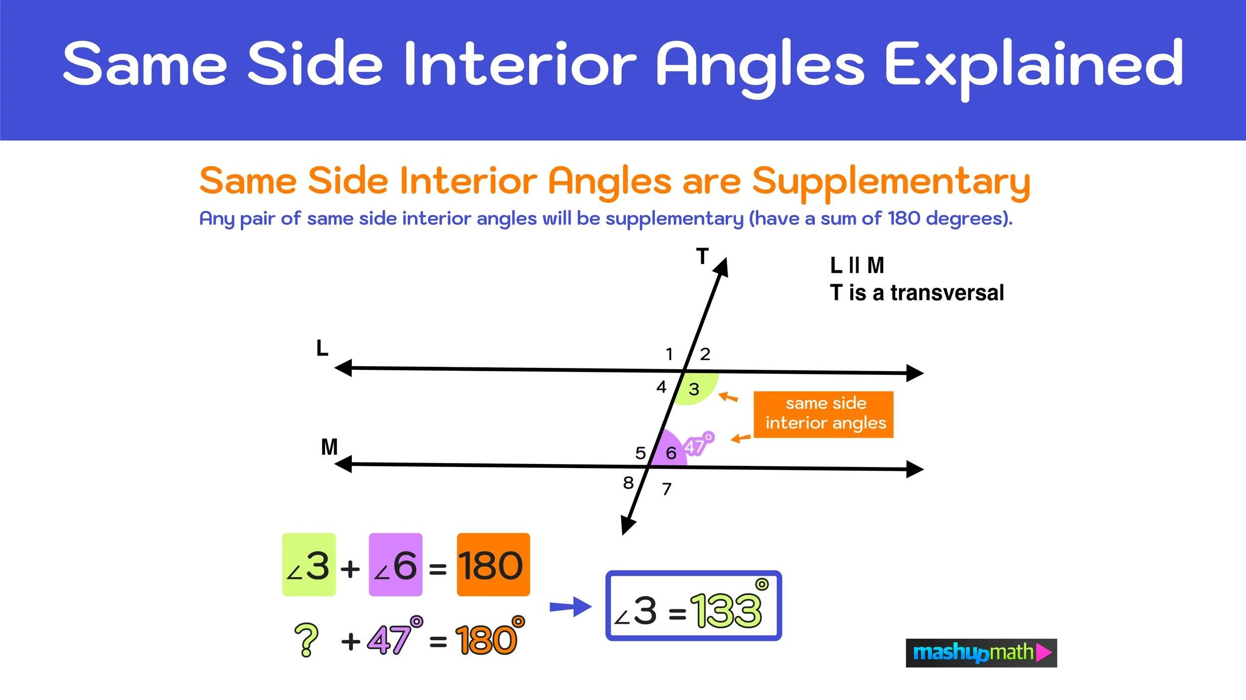
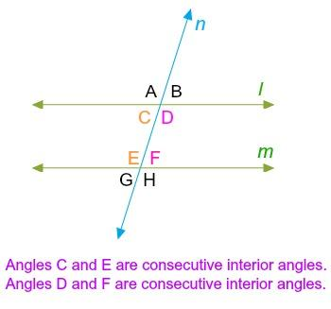

Definition
# Source: AI Source: Provided by: [Data Path: Persons Table -> ID Column: 1, Name_En Column: Motasem Essam] -> From: [ChatGPT] on [7/25/2026]
Same-Side Interior Angles (also called Consecutive Interior Angles or Co-Interior Angles) are a pair of angles that lie between two lines and on the same side of a transversal.
When the two lines are parallel, the measures of same-side interior angles always add up to (180^\circ), making them supplementary angles.

Characteristics
# Source: AI Source: Provided by: [Data Path: Persons Table -> ID Column: 1, Name_En Column: Motasem Essam] -> From: [ChatGPT] on [7/25/2026]
Same-side interior angles:
- Are formed when a transversal intersects two lines.
- Lie between the two lines (interior region).
- Lie on the same side of the transversal.
- Share the same transversal but are at different intersections.
- Are supplementary only if the two lines are parallel.

Illustration
# Source: AI Source: Provided by: [Data Path: Persons Table -> ID Column: 1, Name_En Column: Motasem Essam] -> From: [ChatGPT] on [7/25/2026]
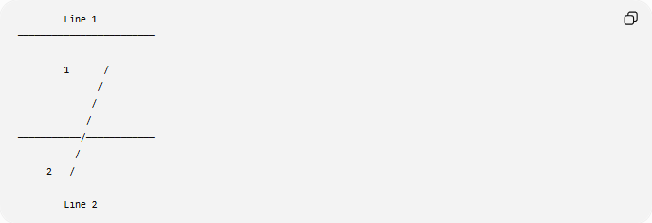
Line 1
────────────────────────

1 /
/
/
/
───────────/────────────
/
2 /

Line 2
Angles 1 and 2 are same-side interior angles because they:
- Are between the two lines.
- Are on the same side of the transversal.

Mathematical Representation
# Source: AI Source: Provided by: [Data Path: Persons Table -> ID Column: 1, Name_En Column: Motasem Essam] -> From: [ChatGPT] on [7/25/2026]
If:
$$l_{1}∥l_{2}$$
and a transversal intersects them, then:
$$m∠A+m∠B={180}^{∘}$$
or
$$θ_{1}+θ_{2}={180}^{∘}$$

Same-Side Interior Angles Theorem

Theorem
# Source: AI Source: Provided by: [Data Path: Persons Table -> ID Column: 1, Name_En Column: Motasem Essam] -> From: [ChatGPT] on [7/25/2026]
If two parallel lines are cut by a transversal, then each pair of same-side interior angles is supplementary.
Therefore,
$$m∠1+m∠2={180}^{∘}$$

Converse Theorem
# Source: AI Source: Provided by: [Data Path: Persons Table -> ID Column: 1, Name_En Column: Motasem Essam] -> From: [ChatGPT] on [7/25/2026]
If two lines are cut by a transversal and a pair of same-side interior angles is supplementary,
$$m∠1+m∠2={180}^{∘}$$
then the two lines are parallel.

Example 1
# Source: AI Source: Provided by: [Data Path: Persons Table -> ID Column: 1, Name_En Column: Motasem Essam] -> From: [ChatGPT] on [7/25/2026]
Given:
$$m∠1={70}^{∘}$$
Find:
$$m∠2$$
Solution:
$${70}^{∘}+∠2={180}^{∘}$$
$$∠2={110}^{∘}$$

Example 2
# Source: AI Source: Provided by: [Data Path: Persons Table -> ID Column: 1, Name_En Column: Motasem Essam] -> From: [ChatGPT] on [7/25/2026]
Given:
$$m∠A={\left(4x+20\right)}^{∘}$$
$$m∠B={\left(2x+40\right)}^{∘}$$
Since they are same-side interior angles,
$$\left(4x+20\right)+\left(2x+40\right)=180$$
$$6x+60=180 \\ 6x=120 \\ x=20$$
Then:
$$m∠A={100}^{∘}$$
$$m∠B={80}^{∘}$$

Position of Same-Side Interior Angles
# Source: AI Source: Provided by: [Data Path: Persons Table -> ID Column: 1, Name_En Column: Motasem Essam] -> From: [ChatGPT] on [7/25/2026]
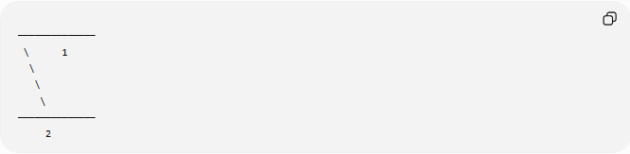
──────────────
\ 1
\
\
\
──────────────
2
Both angles:
- Are inside the parallel lines.
- Are on the same side of the transversal.

Relationship with Other Angles
# Source: AI Source: Provided by: [Data Path: Persons Table -> ID Column: 1, Name_En Column: Motasem Essam] -> From: [ChatGPT] on [7/25/2026]
When two parallel lines are cut by a transversal:
- Corresponding angles are equal.
- Alternate interior angles are equal.
- Alternate exterior angles are equal.
- Same-side interior angles are supplementary.

Real-World Examples
# Source: AI Source: Provided by: [Data Path: Persons Table -> ID Column: 1, Name_En Column: Motasem Essam] -> From: [ChatGPT] on [7/25/2026]
Same-side interior angles appear in:
- Railroad tracks crossed by a road.
- Bridge supports.
- Stair railings.
- Parallel fences crossed by a path.
- Architectural beams.
- Engineering blueprints.

Applications
# Source: AI Source: Provided by: [Data Path: Persons Table -> ID Column: 1, Name_En Column: Motasem Essam] -> From: [ChatGPT] on [7/25/2026]
Same-side interior angles are used in:
- Plane Geometry
- Coordinate Geometry
- Parallel Line Analysis
- Engineering
- Architecture
- Construction
- Surveying
- CAD (Computer-Aided Design)
- Technical Drawing
- Computer Graphics

Advantages
# Source: AI Source: Provided by: [Data Path: Persons Table -> ID Column: 1, Name_En Column: Motasem Essam] -> From: [ChatGPT] on [7/25/2026]
Studying same-side interior angles helps to:
- Determine unknown angle measures.
- Prove lines are parallel.
- Analyze transversal relationships.
- Solve geometry proofs.
- Understand supplementary angle relationships.

Limitations
# Source: AI Source: Provided by: [Data Path: Persons Table -> ID Column: 1, Name_En Column: Motasem Essam] -> From: [ChatGPT] on [7/25/2026]
Same-side interior angles are supplementary only when:
- Two lines are parallel.
- A transversal intersects both lines.
If the lines are not parallel, the angles are not necessarily supplementary.

Comparison with Other Angle Relationships
# Source: AI Source: Provided by: [Data Path: Persons Table -> ID Column: 1, Name_En Column: Motasem Essam] -> From: [ChatGPT] on [7/25/2026]
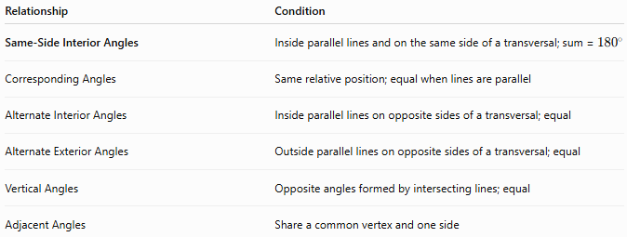
Relationship | Condition
Same-Side Interior Angles | Inside parallel lines and on the same side of a transversal; sum = ${180}^{∘}$
Corresponding Angles | Same relative position; equal when lines are parallel
Alternate Interior Angles | Inside parallel lines on opposite sides of a transversal; equal
Alternate Exterior Angles | Outside parallel lines on opposite sides of a transversal; equal
Vertical Angles | Opposite angles formed by intersecting lines; equal
Adjacent Angles | Share a common vertex and one side

Key Points
# Source: AI Source: Provided by: [Data Path: Persons Table -> ID Column: 1, Name_En Column: Motasem Essam] -> From: [ChatGPT] on [7/25/2026]
- Same-Side Interior Angles lie:
  - Between two lines.
  - On the same side of a transversal.
- If the lines are parallel:
$$m∠1+m∠2={180}^{∘}$$
- They are always supplementary under this condition.
- Their converse theorem is commonly used to prove that two lines are parallel.

Conclusion
# Source: AI Source: Provided by: [Data Path: Persons Table -> ID Column: 1, Name_En Column: Motasem Essam] -> From: [ChatGPT] on [7/25/2026]
Same-Side Interior Angles are two angles located between two lines on the same side of a transversal. When the lines are parallel, these angles are always supplementary, meaning their measures add up to ${180}^{∘}$. This relationship is a fundamental theorem in geometry and is widely used in plane geometry, coordinate geometry, engineering, architecture, construction, surveying, CAD, technical drawing, and computer graphics for solving angle problems and proving line parallelism.

